You are given a rows x cols matrix grid representing a field of cherries where grid[i][j] represents the number of cherries that you can collect from the (i, j) cell.

You have two robots that can collect cherries for you:

* **Robot #1** is located at the **top-left corner** (0, 0), and
* **Robot #2** is located at the **top-right corner** (0, cols - 1).

Return *the maximum number of cherries collection using both robots by following the rules below*:

* From a cell (i, j), robots can move to cell (i + 1, j - 1), (i + 1, j), or (i + 1, j + 1).
* When any robot passes through a cell, It picks up all cherries, and the cell becomes an empty cell.
* When both robots stay in the same cell, only one takes the cherries.
* Both robots cannot move outside of the grid at any moment.
* Both robots should reach the bottom row in grid.

**Example 1:**

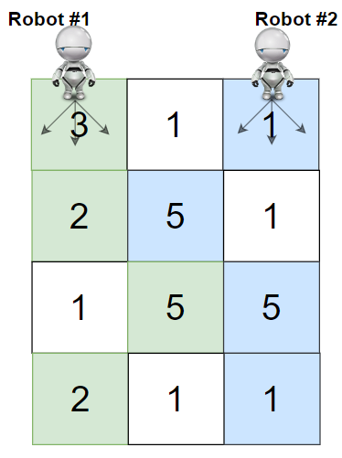

Input: grid = [[3,1,1],[2,5,1],[1,5,5],[2,1,1]]  
Output: 24  
Explanation: Path of robot #1 and #2 are described in color green and blue respectively.  
Cherries taken by Robot #1, (3 + 2 + 5 + 2) = 12.  
Cherries taken by Robot #2, (1 + 5 + 5 + 1) = 12.  
Total of cherries: 12 + 12 = 24.

**Example 2:**

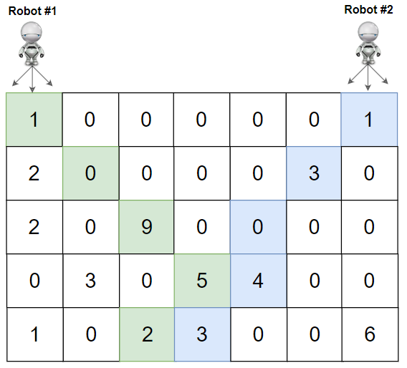

Input: grid = [[1,0,0,0,0,0,1],[2,0,0,0,0,3,0],[2,0,9,0,0,0,0],[0,3,0,5,4,0,0],[1,0,2,3,0,0,6]]  
Output: 28  
Explanation: Path of robot #1 and #2 are described in color green and blue respectively.  
Cherries taken by Robot #1, (1 + 9 + 5 + 2) = 17.  
Cherries taken by Robot #2, (1 + 3 + 4 + 3) = 11.  
Total of cherries: 17 + 11 = 28.

**Constraints:**

* rows == grid.length
* cols == grid[i].length
* 2 <= rows, cols <= 70
* 0 <= grid[i][j] <= 100